1. Multi-Currency Support Implementation

Overview

Multi-currency support allows the donation platform to automatically detect or offer users a choice of currency for their transactions. This improves the donor experience by reducing conversion costs, displaying familiar symbols (e.g., $, €, £), and ensuring that backend systems store and report all data consistently (usually in USD for internal reporting).

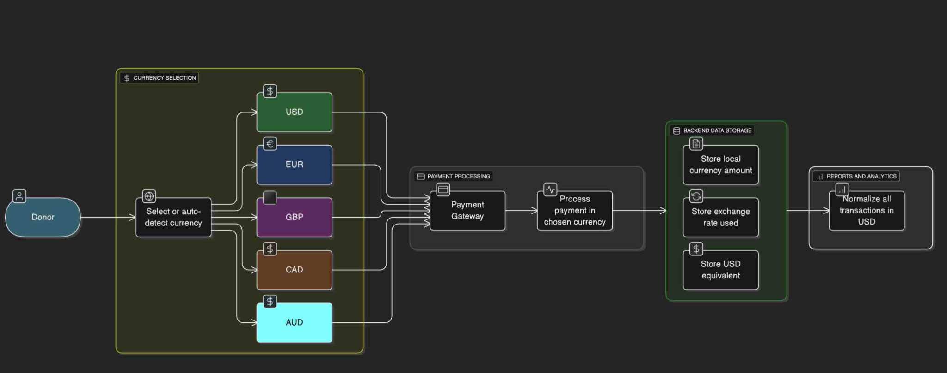

Currencies Included in MVP
Currency | Region | Refined Reason for Inclusion
USD ($) | United States / Global | The primary global donation and settlement currency. Most international payment gateways (Stripe, PayPal, etc.) process donations in USD by default, making it a must-have base currency.
EUR (€) | Europe | Represents the largest single donor market in the EU, with strong adoption across 20+ countries. Supporting EUR minimizes conversion friction for European donors.
GBP (£) | United Kingdom | The UK has a high online donation rate and well-established payment infrastructure. Accepting GBP enhances trust and reduces fees for UK-based contributors.
CAD (C$) | Canada | Canada is a major donor base for North American fundraising platforms, and sharing similar infrastructure with the U.S. makes CAD integration technically straightforward.
AUD (A$) | Australia | Australia has a strong digital payment adoption rate and growing donor engagement in global causes. Supporting AUD opens up contributions from the wider Oceania region.

Implementation Approach

1. Currency Configuration
- The system defines a set of supported currencies for the MVP.
- A default currency (USD) is used for reporting and fallback.
- The configuration can easily expand to include new currencies later.

2. Payment Gateway Integration
- Use a gateway like Stripe or PayPal that already supports global multi-currency transactions.
- When a donor selects a currency, the gateway charges that amount directly without manual conversion.
- Transaction details are stored with both local and converted values (USD equivalent).

3. Front-End Currency Selection
- Donors can choose their preferred currency from a dropdown, or the system can auto-detect based on location (via IP or browser locale).
- Conversion is shown transparently on the donation page (e.g., “You’ll be charged €20 = $21.50 USD”).

4. Data Storage and Reporting
- Each transaction entry includes:
  - Donation amount in local currency
  - Currency code (e.g., EUR, GBP)
  - Exchange rate at time of donation
  - USD equivalent for financial reporting
- This ensures traceability and consistency in both donor receipts and internal analytics.

5. Conversion Logic
- Use a trusted exchange rate API such as OpenExchangeRates or Fixer.io for real-time currency conversion.
- Conversion rates are fetched and cached periodically to reduce API calls.
- The system should always log the exchange rate used for transparency in audits.

Benefits
- Global Reach: Donors from different regions can contribute easily.
- Reduced Friction: Avoids confusion around exchange rates or unfamiliar currency symbols.
- Accurate Reporting: Maintains consistent reporting in a single base currency.
- Future Scalability: Simple architecture allows more currencies to be added later with minimal changes.

Future Enhancements
- Add more currencies (e.g., INR, SGD, JPY) based on donor analytics.
- Introduce multi-language support to match localized currencies.
- Incorporate alternative payment methods (e.g., UPI, SEPA, Apple Pay).
- Enable donor preference storage for recurring donations in their chosen currency.

Determine Currency Types to Include in the MVP
(Inserted above in the implementation).

Why these choices can be considered for MVP
- Covers 5 major global regions (North America, Europe, UK, Oceania)
- Ensures broad donor accessibility with minimal engineering overhead
- Fully supported by Stripe, PayPal, and other major processors
- Keeps the MVP simple, scalable, and internationally relevant

Investigate Conversion Charts and Logic for Currency Conversion
Aspect |  | Explanation | Example / Notes
1. Purpose of Conversion Charts |  | Conversion charts help display how much a donation in one currency equals another. It improves donor transparency and helps users understand real-time value. | Example: “$10 = €9.20 = £7.80”
2. Source of Exchange Rates |  | Use trusted APIs or data providers for real-time exchange rates instead of manually updating rates. | Common APIs: Open Exchange Rates, Fixer.io, CurrencyLayer, ExchangeRate-API, or Stripe’s built-in rates.
3. Frequency of Updates |  | Currency rates change daily (or hourly), so decide how often to refresh them — depending on traffic and need for accuracy. | Example: Update every 12 hours for MVP; real-time updates can be added later.
4. Logic for Conversion |  | The formula is straightforward:
Converted Amount = Base Amount × Exchange Rate |  | Example: $10 × 0.92 (USD→EUR) = €9.20
5. Handling Exchange Rate Fees |  | Payment gateways often apply a small markup to rates. Plan how to handle or display that. | Example: Stripe adds ~2% markup for conversions. We can display “Includes conversion fee.”
6. Rounding and Display Rules |  | Round final converted values to 2 decimal places for clarity and consistency. | Example: Instead of “€9.2374,” display “€9.24.”
7. User Interface (UI) Integration |  | Display the converted currency value on the donation page and allow users to toggle currencies if needed. | Example: “Donate 10 USD (≈ 9.20 EUR)” with a currency dropdown selector.
8. Handling Backend Storage |  | Always store donation amounts in a base currency (usually USD) for consistency and reporting accuracy. | Example: Donor pays €9.20 → store $10 equivalent in database.
9. Dealing with API Limits or Downtime |  | Have fallback rates or cached values in case the API fails. | Cache the last successful response for up to 24 hours.
10. Testing and Validation |  | Verify conversions across multiple currencies and check against official sources (like Google Finance). | Example: Compare $→£ conversions between your API and Google to ensure accuracy.

Multi-Currency Enhancements and Considerations
Based on the team discussion and the initial multi-currency implementation plan, the following enhancements and considerations have been proposed to strengthen the MVP and future scalability:
- Language and Localization Support
To improve the donor experience across regions, the platform will include multi-language support alongside multi-currency functionality. This ensures that donors can interact with the platform in their preferred language (e.g., Spanish, French, German), improving accessibility and engagement. Localization will extend to donation forms, confirmation messages, and currency displays.
- Currency Exchange Rate Providers
Both OpenExchangeRates and Fixer.io offer free plans suitable for small-scale applications:
- OpenExchangeRates: Their free plan provides up to 1,000 API requests per month with hourly updates. It's ideal for applications with moderate traffic and can be utilized for commercial purposes. However, it limits users to USD as the base currency and doesn't support advanced queries.
- Fixer.io: The free plan allows up to 100 API calls per month with hourly updates. It supports over 170 currencies and provides historical data. While it's suitable for low-traffic applications, higher usage may require a paid plan.
- Database and Traffic Handling
Given that the platform uses MongoDB for transaction storage, the system is well-positioned to handle high traffic and concurrent transactions. MongoDB’s flexible document-based model supports storing both local and base currency amounts, exchange rates, and donor metadata efficiently. For high-load scenarios, standard best practices such as indexing critical fields, caching frequent queries, and sharding collections if needed will ensure smooth performance and scalability.

